STANDARD FORMAT OF “LEHENGA DESCRIPTION”


For Online Selling Products
Design Name: CHIKUDI-A
Product Colours NO.: A1
. 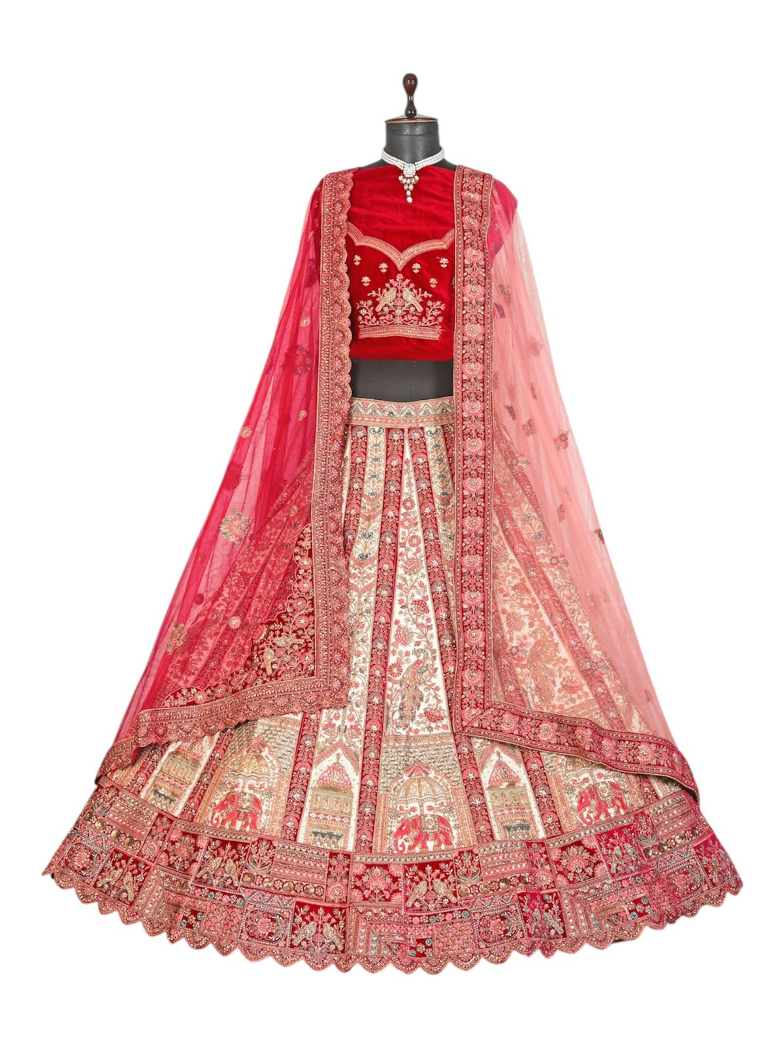
Particulars | Details
Lehenga Fabric | Silk, Italian
Blouse Fabric | Premium Velvet
Dupatta Fabric | Two Net Dupattas
Work Type | Jari, Jarkan – embroidery Work
Colour | Chiku
Pattern | Bridal Designer Lehenga
Stitching Type | Semi-Stitched (Can be customized up to 44")
Occasion | Wedding, Reception, Engagement & Festive Wear
Fit Type | Regular Fit
Care Instructions | Dry Clean Only
Package Contents | 1 Lehenga, 1 Blouse Piece, 2 Dupatta

KEY HIGHLIGHTS
- Crafted from high-quality Silk & Italian fabric
- Velvet blouse provides a royal and rich texture
- Two dupattas included: main net dupatta + secondary net dupatta
- Designed with detailed work to give a grand bridal appeal
- Semi-stitched lehenga supports all body fittings
- Ideal for wedding rituals, photoshoots & reception functions
- Simple yet elegant single chiku colour palette
- Ensures comfort for long bridal events

